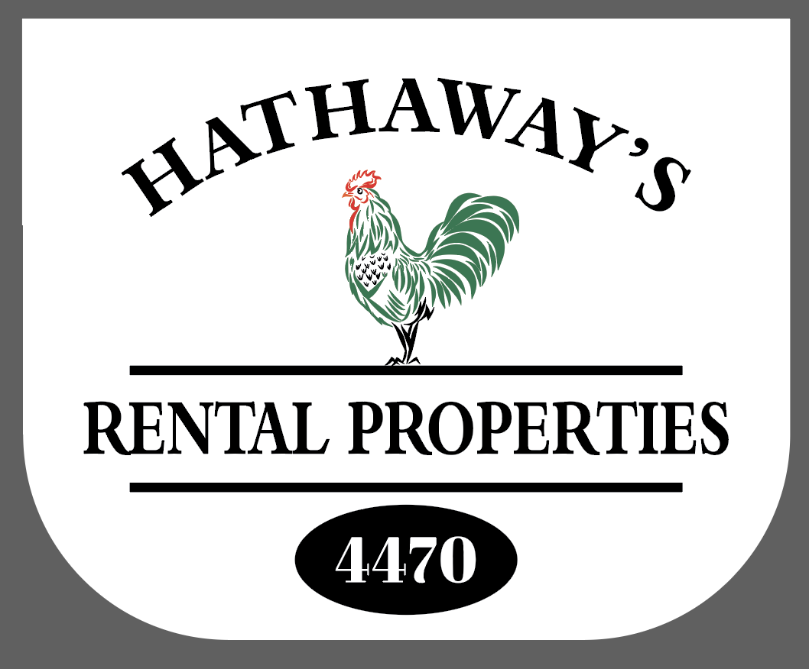 Hathaway Rental Properties
Event Rental Agreement and Policies

When you choose Hathaway Rental Properties for your event, the property becomes a private retreat for you and your guests. In order to incur the exclusive use of the property, we require that all cottages and the farmhouse are rented for the time period of the event. Minimum stay of Friday and Saturday apply. Events are limited to Low Season dates only. The cost for your event varies depending on the amount of events that will be held on property.

____Rehersal Dinner & Wedding $4,000 (regardless of # of guests)
____Wedding Only- Over 60 people $3,000
____Wedding Only- Under 60 people $2,000
____Other Event______________________________________________Cost $_______

MAXIMUM NUMBER OF GUESTS: 125

No Pets Allowed (unless there are special circumstances)

The fee includes the setup and use of one, 20x30, white canopy tent (if needed), trash and recycling receptacles, parking and ceremony on-site if desired. The canopy has no sides and will cover approximately 50 people or less. All additional rental equipment is at the expense of the RENTER.

We require the RENTER to have portable restrooms (or porta-john) for guests over 30. One per 50 guests.

All food and beverage servers must be licensed and insured and pre-approved by Hathaway Rental Properties. All vendors must name Hathaway Rental Properties, LLC as additional insured.

______________________________________________________________________________

Rental Policies

Reservation Deposit: Half of the event fee ($ ) plus 50% of the total cottage rental fee is due at the time of the reservation if the event takes place within the same calendar year as the event. Otherwise, the 50% of the event fee ($ ) is due at the time of the reservation and the 50% deposit for the cottages is due by January 15th of the next calendar year.
Cancellation Policy: If there is a cancellation less than 6 months prior to the date of the event, the deposits will be forfeited. If there is a cancellation prior to 6 months of the date of the event a full reimbursement will be refunded, and half of the deposit (for the event only) will be forfeited by the renter.

Event Insurance: The RENTER agrees to carry Liability Insurance or other equivalent insurance, including alcohol coverage, if required, which shall cover the Hold Harmless Agreement set forth above with minimum limits of liability of $1,000,000.00 each occurrence for bodily injuries and property damage in a company rated “A” or higher by BEST GUIDE.

In addition, the RENTER and GUESTS agree that they will indemnify and hold free and harmless Hathaway Rental Properties, LLC, its owners and agents from any and all claims or actions for damages or loss to property, including the loss of use thereof, and from any and all claims or actions for personal injury, sickness or disease, including personal injury if caused by the RENTER its guests, agents, employees or servants acts or omissions, and the RENTER will pay any and all judgement decrees, costs, including attorney’s fees which may be rendered against Hathaway Rental Properties LLC its directors, officers, agents and employees, in any and all such actions of proceedings.

Property: The RENTER has access to the entire grounds including the pool area, picnic tables and grills, fire pits etc. The RENTER agrees to keep premises in good repair and deliver the premises in like condition as when taken, with the exception of reasonable wear and tear and damage by natural elements. All items brought onto the premises for the event, including food items, decorations etc. must be removed by the RENTER. The RENTER AND GUESTS shall also be responsible to comply with the cottages and farmhouse policies posted on the info@hathawayscottages.com website as well as all the laws and all the rules, ordinances or requirements imposed by any municipality or government authority and will not do or suffer to be done anything on said premises in violation of thereof.

I/We have read and understood this agreement and the policies it contains.

___________________________________________________________________________
Renter Date

____________________________________________________________________________
Hathaway Rental Properties, LLC Authorized Agent Date

